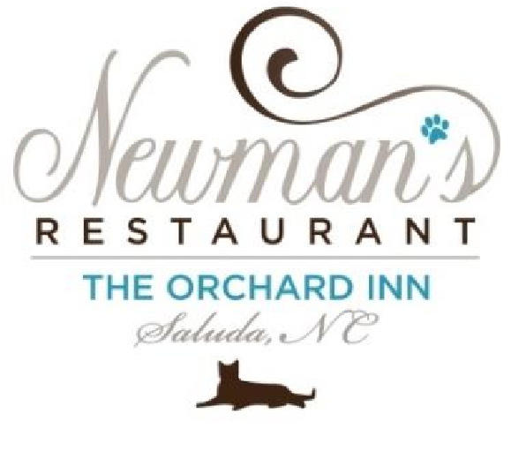
Dinner Menu - March 2024
First Course:

Grilled Romaine Caesar Salad, Herbed Croutons, shaved Parmesan, White Silano Anchovies
or

Roasted Red Pepper and Sun-Dried Tomato Soup, Herbed Croutons, Chives, Crème Fraîche
or
Cheese Plate of Hornbacher, Triple Cream Brie and Manchego, Cherry Tomatoes, Fig Jam, Olive Tapenade, Crostini
or
Virginia Peachtree Oysters on the Half Shell, Cocktail Sauce
Second Course:

Pan Seared N.C. Shrimp, Fried Green Tomato, Jícama Pineapple Slaw
or

“Cacio e Pepe” Fettuccini, Parmigiano Reggiano, Black Pepper
or
Beef Tartare, Celery Leaf Salsa Verde, Oreno Greek Olive Oil, Grated Cured Egg Yolk, Grilled Bread

Main Course:

Roasted Duck Confit,

Potato Pavé, Mango Chutney, Haricots Verts, Grilled Apple, Sauce Cumberland, Demi Glace
or
Grilled Beef Tenderloin, Mashed Potatoes, Carrot Purée, English Peas, Cipollini, Mushrooms, Port Wine Sauce
or
Pan Seared Trout Almondine, Rice Grits, Carrots, Spinach, Grilled Tomato, Jícama Pineapple Slaw, Parsnip Purée
or
Vegetarian Plate:

Pan Fried Tofu, Rice, Seasonal Vegetables, Jicama Pineapple Slaw, Roasted Walnuts
or
Pan Seared New Zealand Lamb Chops, Potato Pavé, Asparagus and Baby Carrots, Maitake Mushrooms, Grilled Apple, Demi-Glace

Dessert:

Viennese Apple Strudel (with Cinnamon and Walnuts), Whipped Cream
or Chocolate Decadence Cake, Strawberries, Whipped Cream

